“Silent No More: How Our AI Product is Revolutionizing Communication”

AI has been tremendously trying to cover significant problems & provide accessible solution along with assistive technologies. It has created its own space in the market. Still, it is undergoing a range of modifications to cope up with the issues efficiently. Here are some ways in which AI has contributed in enhancing the lives of disabled people:

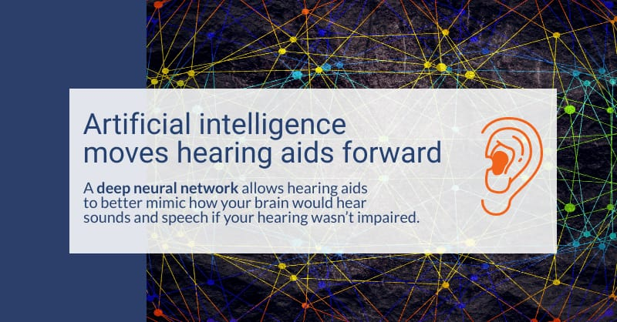

1. Accessible public transportation:

* Ramps and bridge plates
* Priority seating for the disabled
* Wayfinding and Navigation
* Audio and Visual Information-Digital displays or announcements provides real-time information about upcoming stops

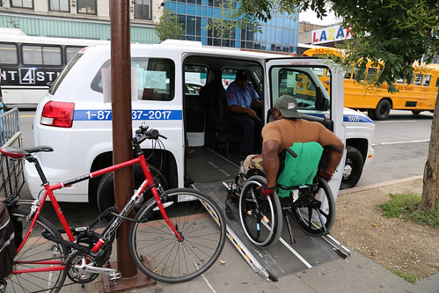

1. Health monitoring:

* Wearable devices facilitate with sensors which can track signs such as blood pressure, oxygen saturation and even body movement.
* Remote monitoring allows healthcare providers to keep track of person’s health from a distance.

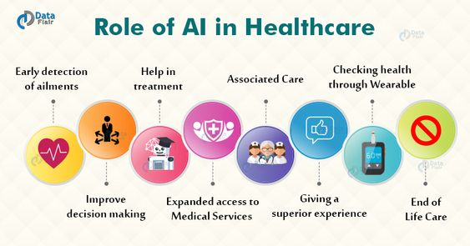

1. Home Automation (Smart home technology):

* Smart smoke detectors and carbon monoxide detectors can alert caretakers in the event of a medical emergency.
* Voice-controlled virtual assistants like Amazon Alexa, Google Assistant and Apple Siri provide hands-free control.



1. Speech and Communication Aids:

* Text-to-Speech (TTS) Software
* Speech-to-Text (STT) Software
* Eye Gaze and Head Tracking Systems- For individuals with severe motor impairments who cannot use their hands to interact with devices.

1. Accessible Information and Learning:

* AI algorithms can convert written content into various formats, such as Braille or audio, making information more accessible to visually impaired individuals.
* AI-powered educational platforms can customize learning experiences based on individual needs and learning styles.

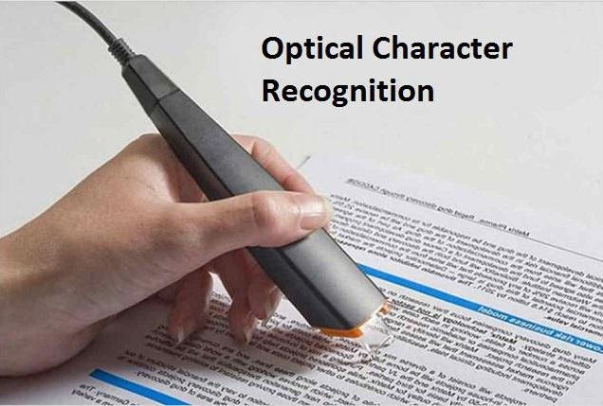

1. Virtual reality (VR) and augmented reality (AR):

* VR and AR can be used to create immersive and interactive learning experiences that can help people overcome physical and cognitive barriers.
* For example, VR can be used to help people with mobility impairments to practice walking, and AR can be used to help people with visual impairments to read and navigate their surroundings.

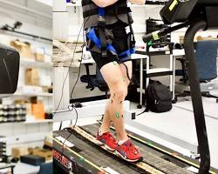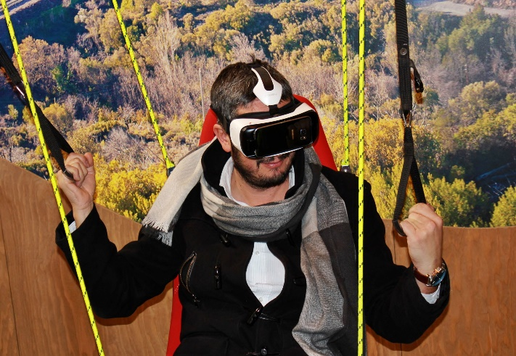

1. Creating employment possibilities:

* Screen readers, magnification tools, and adaptive keyboards help visually impaired individuals use computers and mobile devices.
* Voice command technology allow these individuals to navigate the screen through speech.
* Additionally, eye-tracking tools like Intelligaze present new ways for these individuals to navigate computer and tablet devices.



Deaf person using sign language to communicate to a coworker.

1. Emotional Support and Mental Health:

* Chatbots and virtual companions: Provide a safe and non-judgmental space for individuals to express their emotions and seek support.
* Text and Sentiment Analysis: To understand and interpret human emotions expressed through written communication.

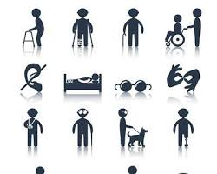

A person with a disability using assistive technology to do something they enjoy.

Summing-up by talking about ‘Stephen Hawking’ who had a motor neuron disease known as amyotrophic lateral sclerosis which affected his muscles and speech. He used a voice synthesizer to communicate which was a basic form of AI. Therefore, Positive transformation in life of Stephen Hawking shows how AI has revolutionised the way of living by shaping the lives of differently abled. Overall, AI and technology hold immense potential in breaking down barriers, improving accessibility, and empowering physically challenged individuals to lead more independent, fulfilling lives.

